**DIGITAL MARKETING ASSIGNMENT**

**NAME:** T. MANI KANDAN

**NAAN MUDHALVAN ID**: D2AB12DD94E7E9F8D424AE527C64862B

1.Create a blog or website using Blogspot and WordPress. Customize the theme design and post new article with 500 words.

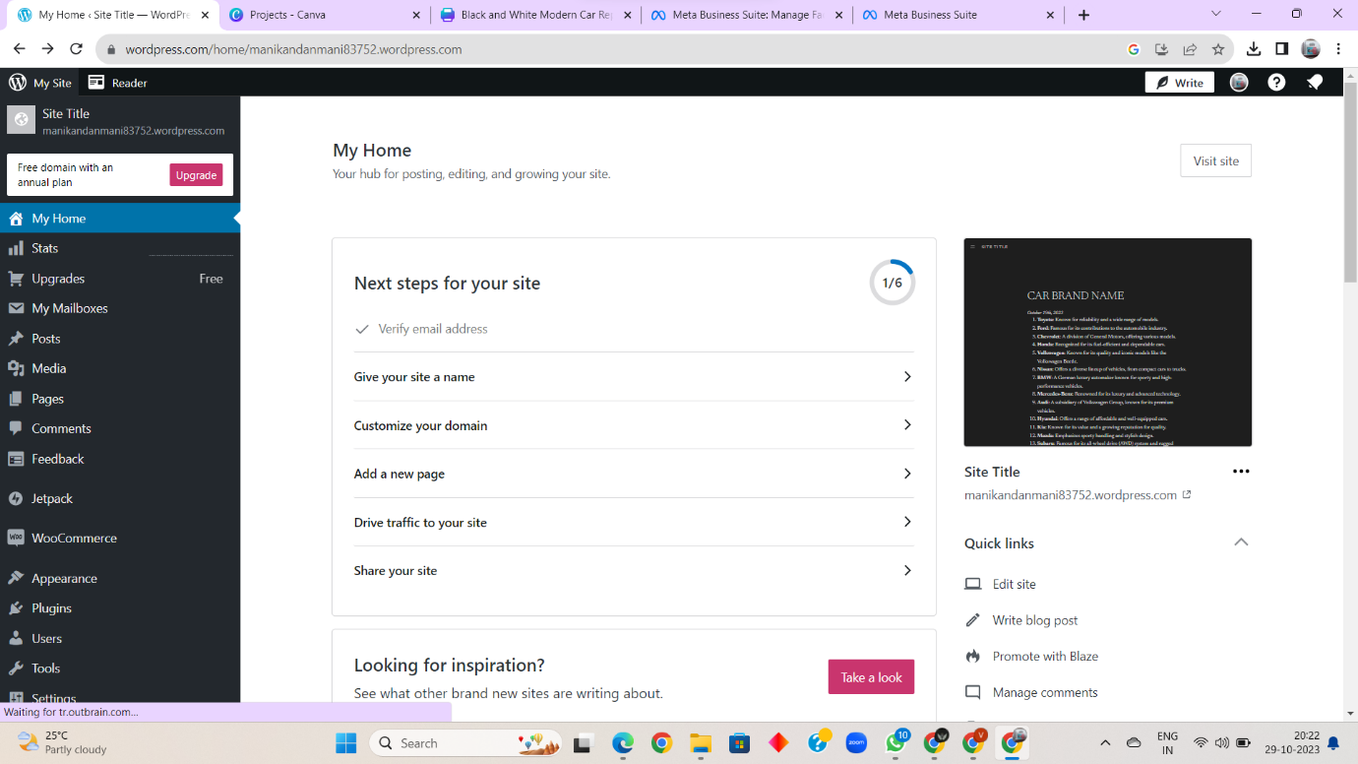

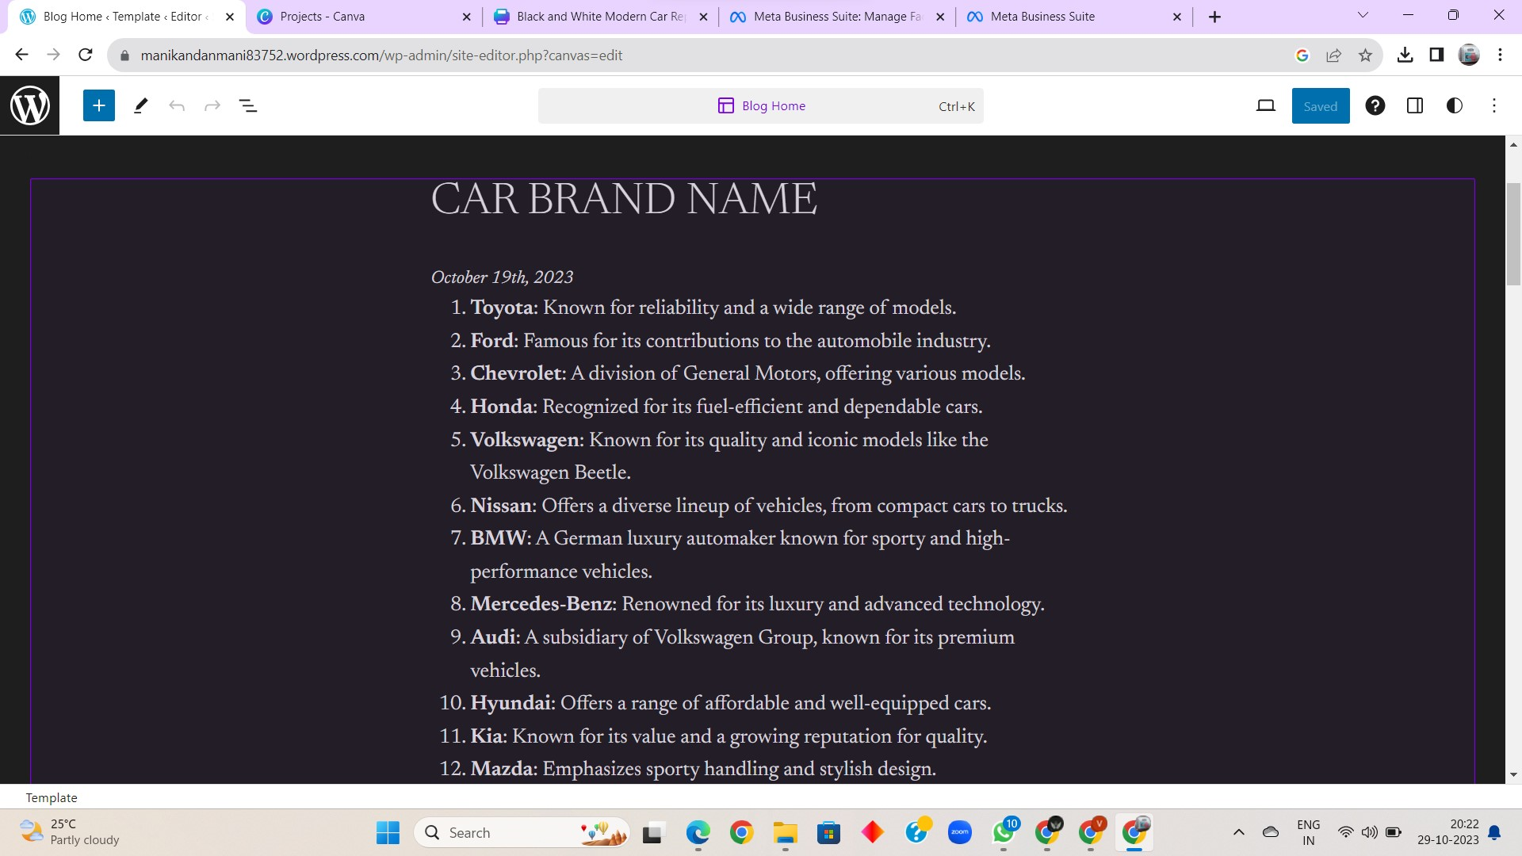

LINK:

<https://manikandanmani83752.wordpress.com/>

2. Create a New Facebook Business Page and post one social media poster for your brand.

SCREENSHOT: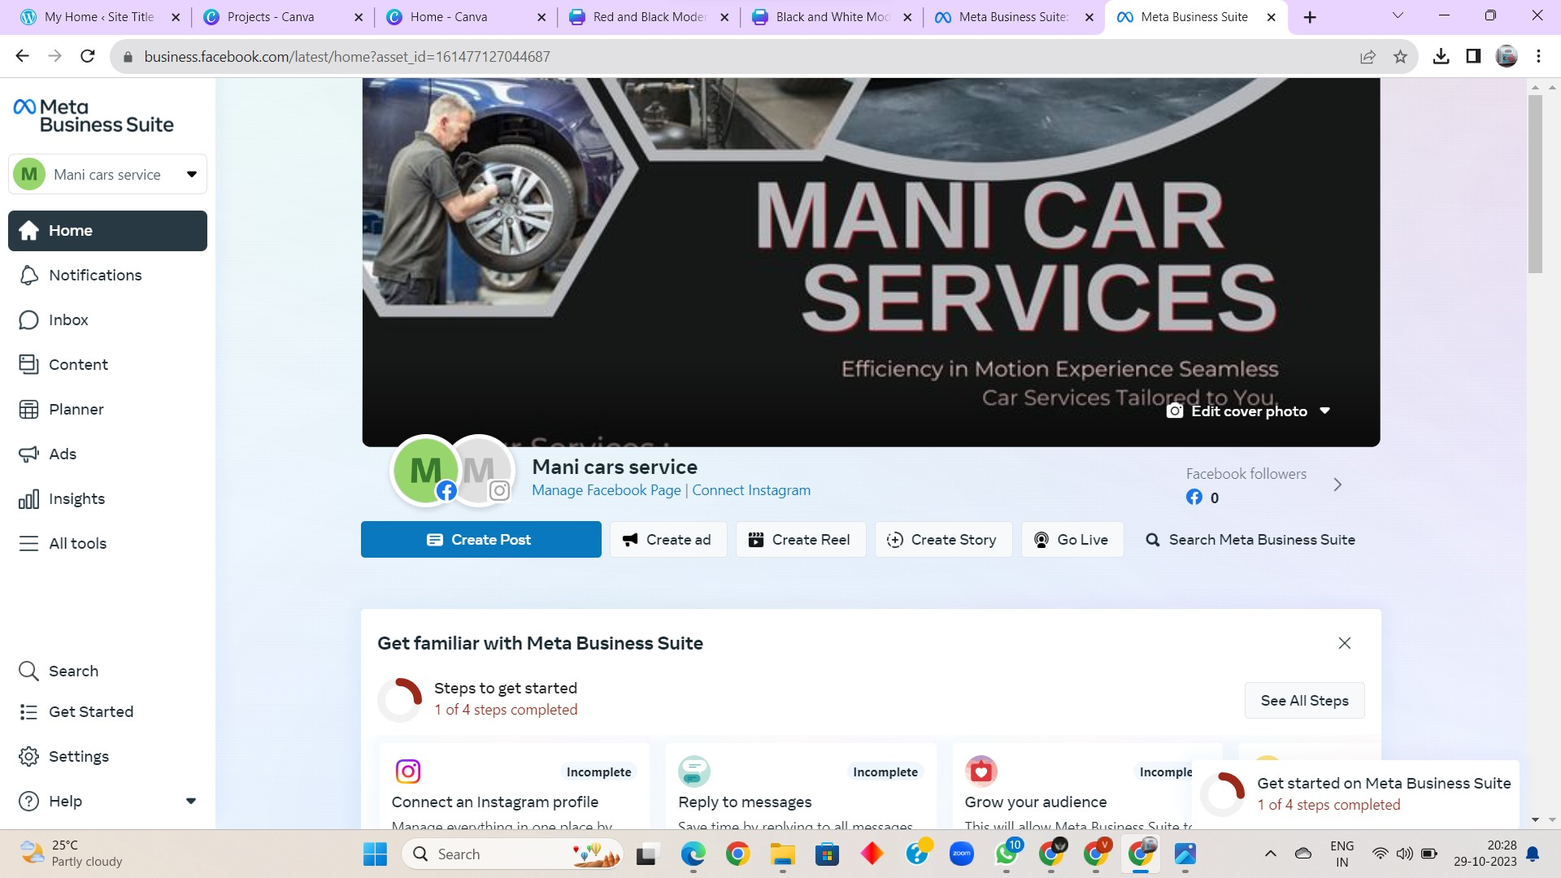

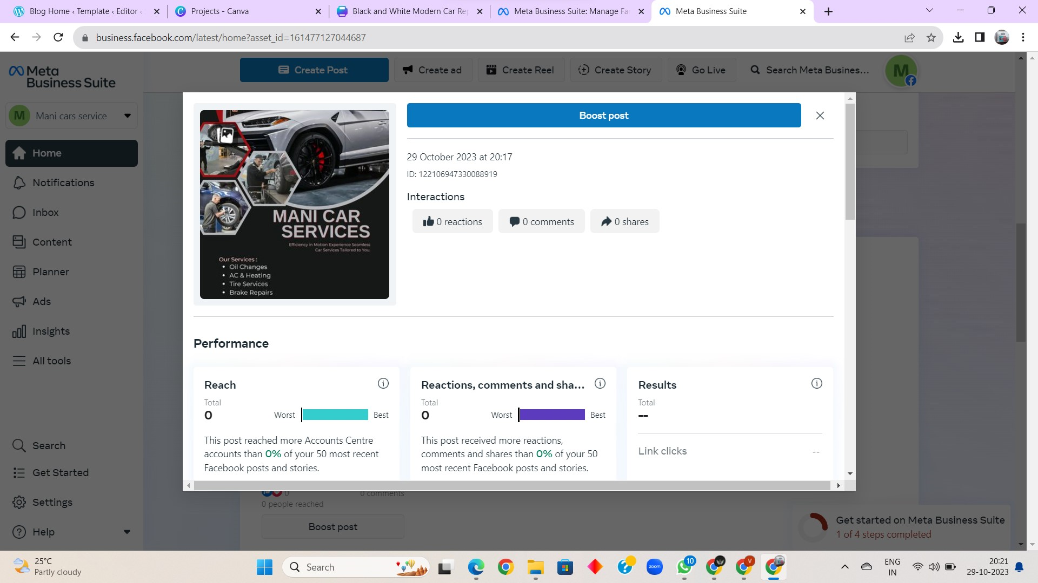

PROFILE LINK:

<https://www.facebook.com/manicarservice>

POSTER LINK:

<https://business.facebook.com/photo.php?fbid=122106955412088919&set=a.122106955430088919&type=3>

3. Create and design a social media advertisement poster using canva.

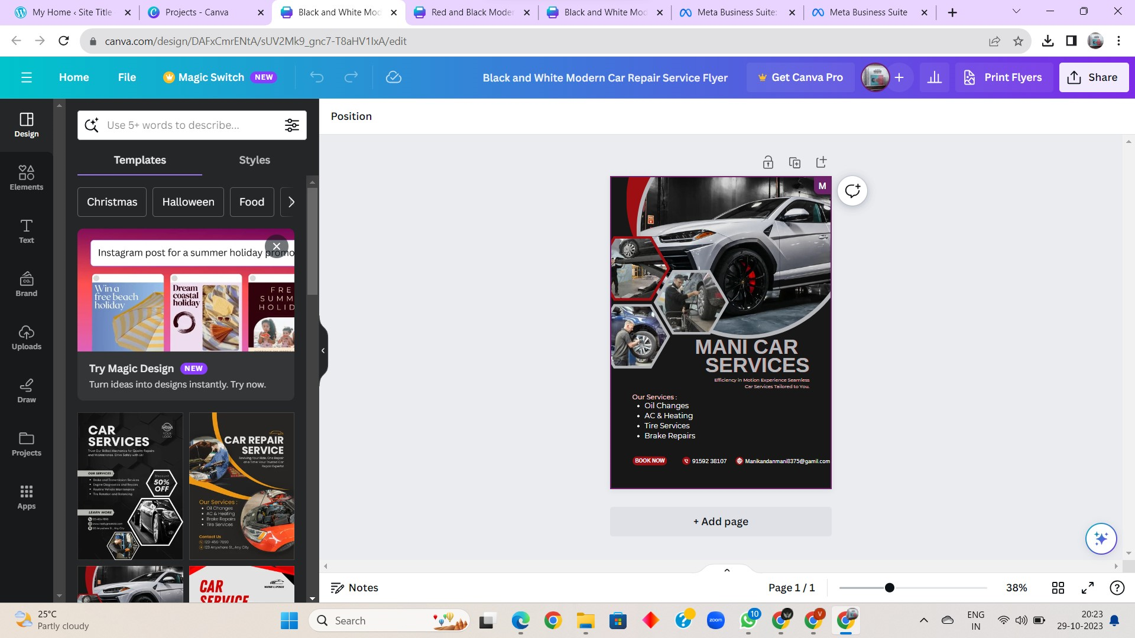

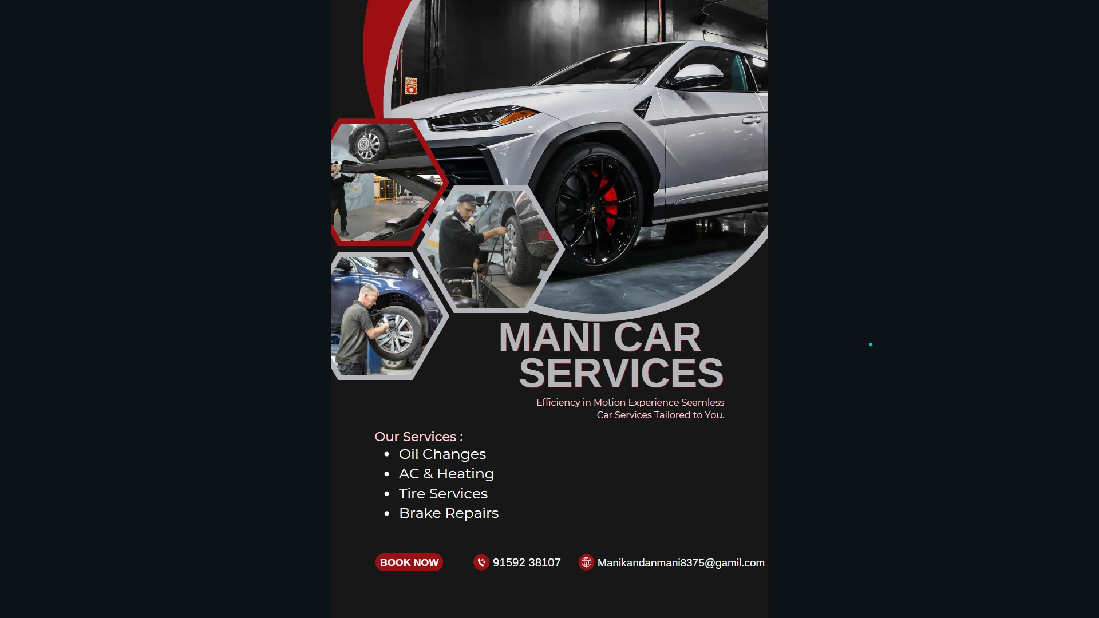

LINK:

<https://www.canva.com/design/DAFxCmrENtA/TS27LpapcrwRM1a6AjoOBg/view?utm_content=DAFxCmrENtA&utm_campaign=designshare&utm_medium=link&utm_source=editor>

4. Create email newsletter design using MailChimp or canva tool.

SCREENSHOT:

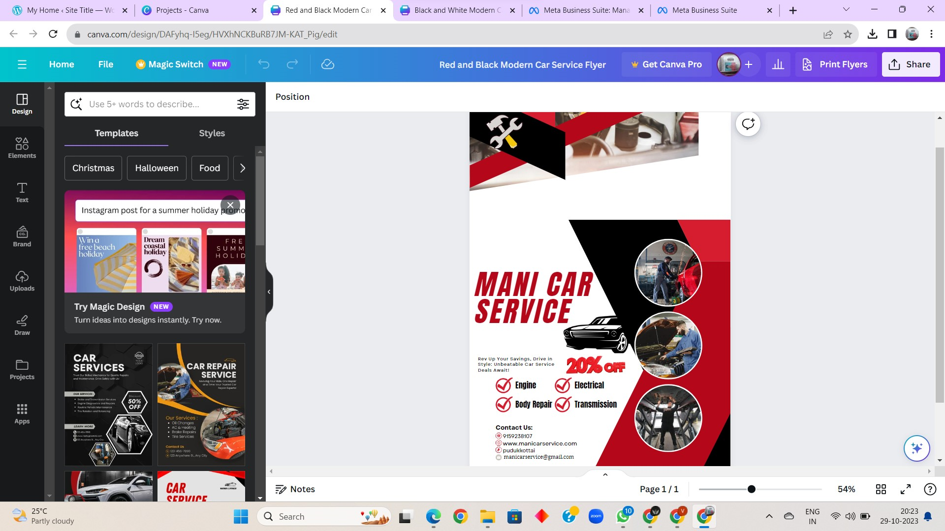

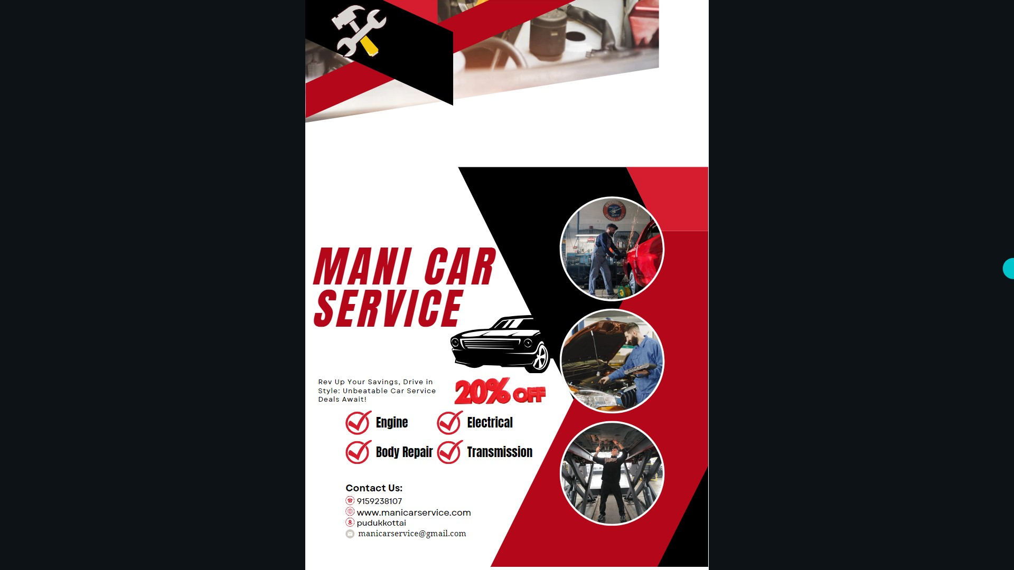

LINK:

<https://www.canva.com/design/DAFyhq-I5eg/MmBPe6ZUnDtUshsEKU5Epg/view?utm_content=DAFyhq-I5eg&utm_campaign=designshare&utm_medium=link&utm_source=editor>